**Take-home assignment for Computer Vision & Machine Learning Scientist role**

**Introduction:**

The general idea in this assignment is to exploit existing neural networks (either trained on ImageNet or remote-sensing data sets) and to explore capabilities related to varying scales of spatial resolution. The selected downstream task is Content-Based Image Retrieval (CBIR).

**Literature Review:**

Dive into recent publications on CBIR and object detection, focusing on methods designed for or adaptable to multi-scale object detection and retrieval.

For your convenience, we have included 2 publications that can serve as a starting point.

**Data sets**

We have provided subsets from 3 data sets that you can exploit for the following tasks.

Data set 1: RESISC-45

Resolution: 256x256 RGB

Classes: Ship, Airplane, Bridge

Portion from dataset: 700 from each class, total 2100 images

Size: 21.2 MB

Data set 2: FAIR1M

Resolution: 1500x1500 RGB

Classes: Ship, Airplane, Neighborhood

Portion from dataset: 30 from each class, total 90 images

Size: 406 MB

Data set 3: Custom Sentinel-2 Dataset

Resolution 224x224 RGB

Classes: Ship, No-Ship

Portion from dataset: 894 No-Ship, 1015 Ship , total 1909 images

Size: 8.01 MB

Sample images from each data set are provided in the last section.

**Data Analysis & Preprocessing:**

Examine and visualize samples from each dataset to understand the varying scales of the objects. Preprocess and split each dataset into training, validation, and testing subsets.

**Feature Extraction & CBIR Implementation:**

Choose and/or modify pre-trained models suitable for extracting features from images with varying object scales. The link for the available pretrained models can be found in the Resources section. You can of course always choose to build your own model if you prefer.

Implement a CBIR system which consists of **feature representation, feature indexing and feature similarity measuring** (Hint: simple KDTree will suffice for feature indexing).

**Evaluation:**

Evaluate the CBIR system's performance qualitatively and/or quantitatively. The evaluation scheme is up to the candidate, e.g. train on multiple data sets, and evaluate performance on the remaining, etc. Remember the scope of this assignment which is to explore neural network capabilities related to varying scales of spatial resolution.

For your benefit, there are multiple metrics that can be defined to assess the CBIR underlying models. The following high-level scenarios can be considered to define appropriate metrics:  
- Same object, same background, different image augmentations (any affine, colour augmentations, etc.)

- Same object, different background (e.g. the same boat but located elsewhere)

- Same sub-category of object (e.g. given fishing boats, returns fishing boats)

- Same category of object (e.g. given a ship, returns ships)

**Post-processing:**

Analyze the CBIR system's potential weak spots, especially concerning small objects. Methods such as Gradcam can be used in this step. Provide an overview of your findings.

**Data set 1 examples:**

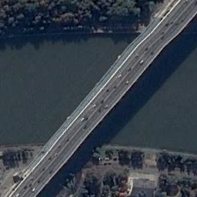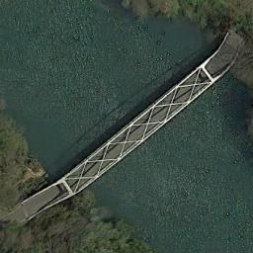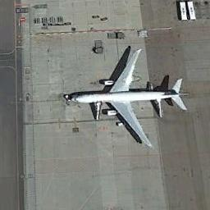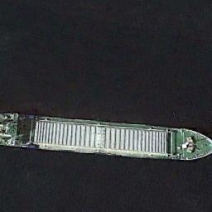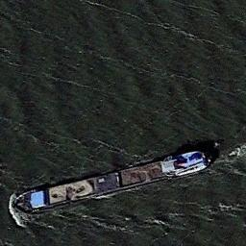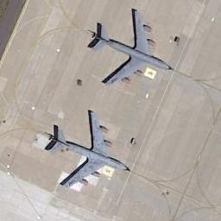

**Data set 2 examples:**

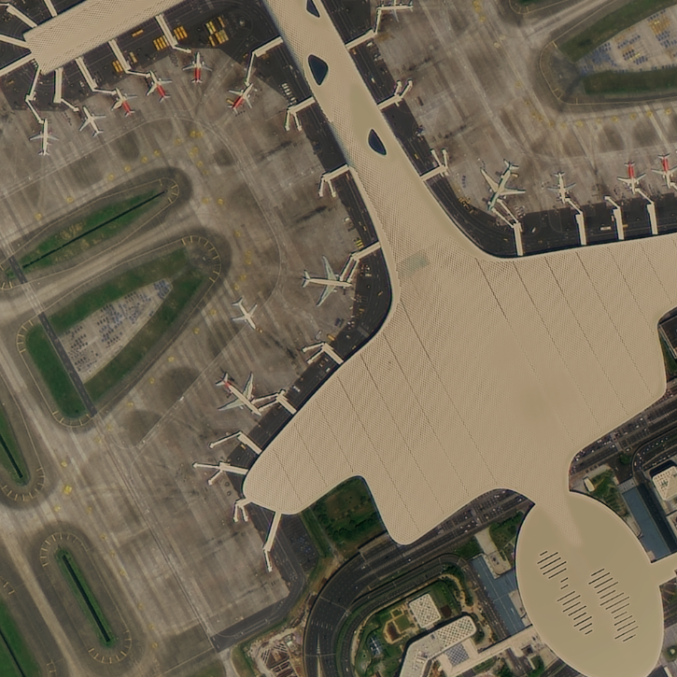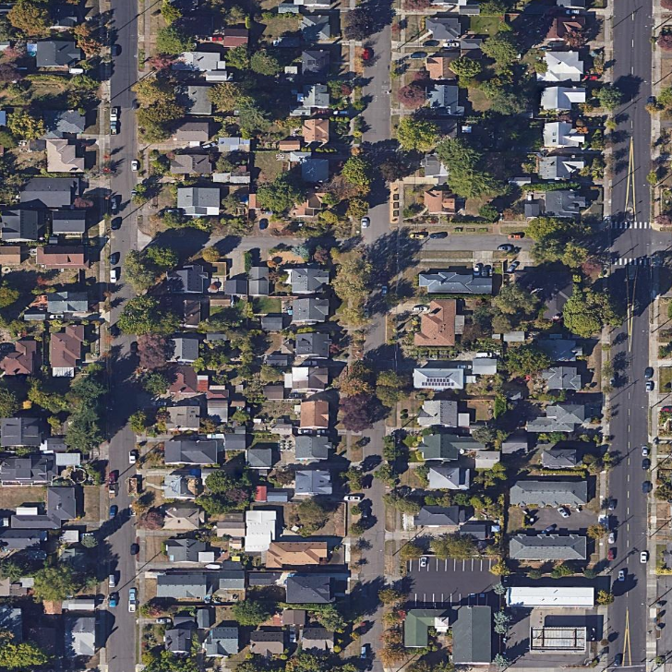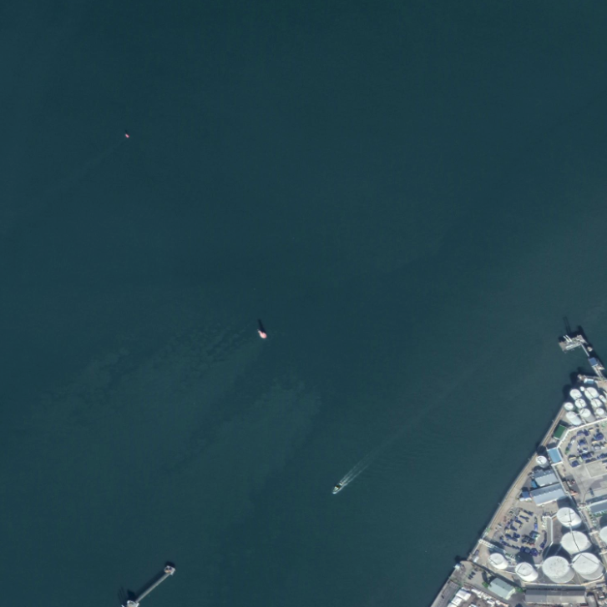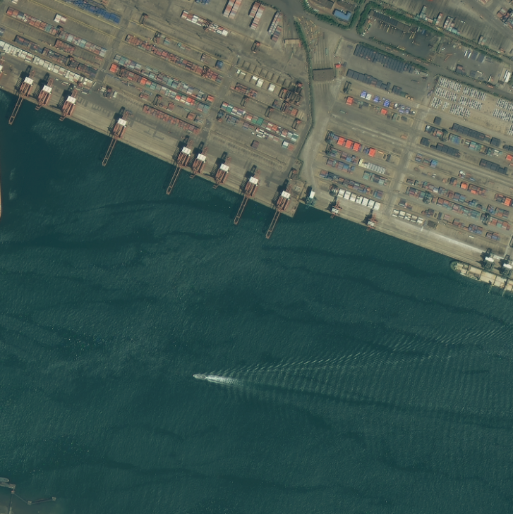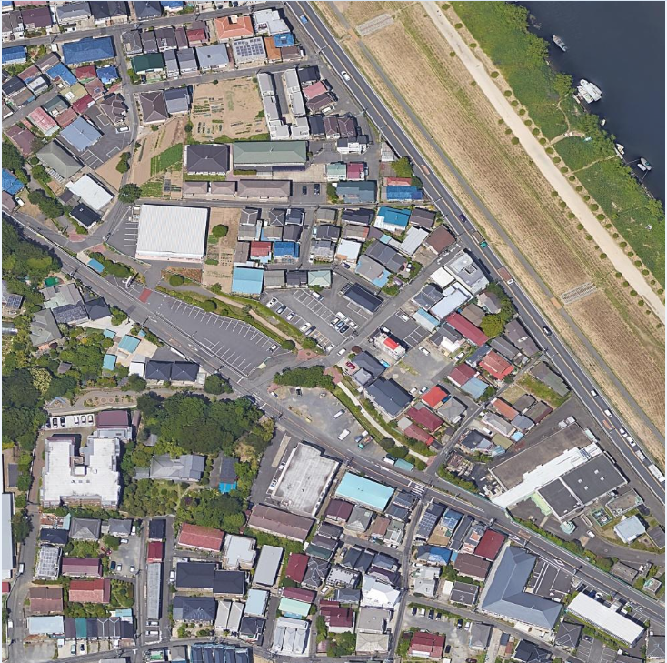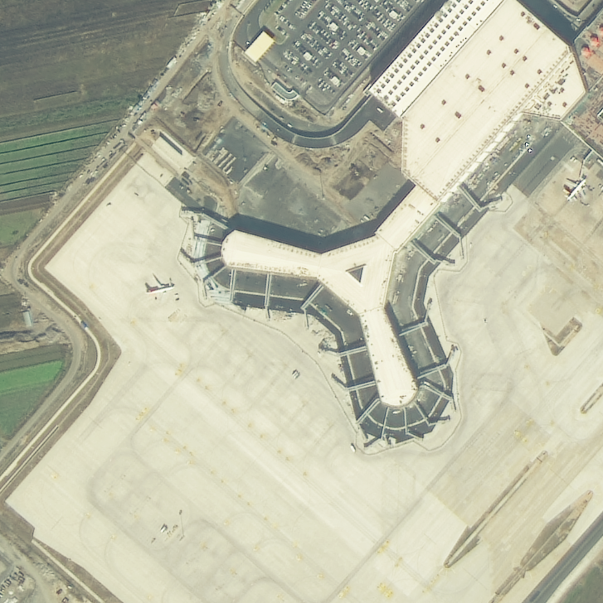

**Data set 3 examples:**

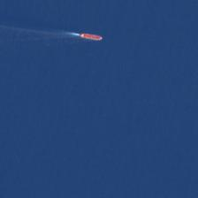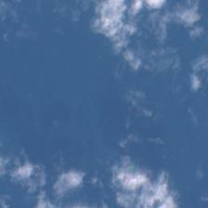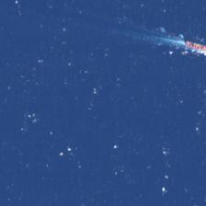

**Resources:**

Papers included in zip file. Github repositories that may be useful:

Repository 1: https://github.com/biasvariancelabs/aitlas

Repository 2: https://github.com/biasvariancelabs/aitlas-arena

Pretrained models: https://drive.google.com/drive/folders/1lTnPsMyyLv9XoPu3cMmE_h6NPkj_WCH8

Suggested deliverables:

* A github repository and/or a jupyter notebook containing all relevant code, visualizations, and results.
* A document that provides introduction (background & related work), motivation for current work, methodology, results, and conclusion sections.

Copyright © [2023], Cyprus Marine and Maritime Institute. All rights reserved.

EU (*) CMMI was established by the CMMI/MaRITeC-X project as a “Centre of Excellence in Marine and Maritime Research, Innovation and Technology Development” and has received funding from the European Union’s Horizon 2020 research and innovation program under grant agreement No. 857586; and matching funding from the Government of the Republic of Cyprus.